Sample “Lead Form” for FACEBOOK
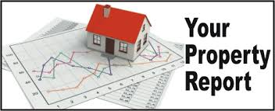

ABC REAL ESTATE PTY LTD
FREE MARKET REPORT WITH THE LATEST SALES IN YOUR AREA
This Report is a must for Seller’s and it automatically generates a list of all the listings on the market now which you will be competing against if you decide to sell, as well as the actual sale price of properties in your area.
Just enter your address, your name and email, and it will generate the report which will be emailed to you.
Email …………………………………………………………………………………..
Full name …………………………………………………………………………….
Street address ……………………………………………………………………..
State ………………… Postcode……………………….

